IRM2005 – Lab 1 – 10%

Due by Wednesday, September 22, 2021 (midnight) in Brightspace

**Part 1 – Personal name authorities**

Pick any 5 books that you have access to (from your house, the internet, the library, etc.). Take a picture/screenshot of the title page (title and author information is required in the image), attach it to your lab submission, and then find, and include in your lab, the appropriate personal name authority in LC Authorities for it.

Example:

Screenshot image

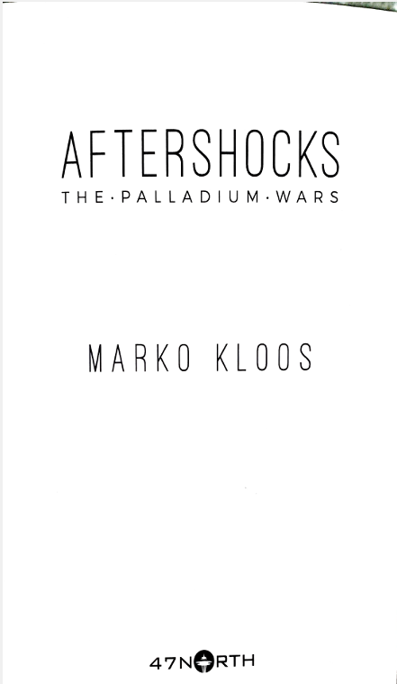

LC Authority for Marko Kloos



**Part 2 – Series authorities**

Pick any 5 books that you have access to (from your house, the internet, etc.) that are part of a series (any series). Take a picture/screenshot of title page and then a second picture/screenshot of the series statement, attach it to your lab submission, and then find, and include in your lab, the appropriate series authority in LC Authorities for it.

Example:

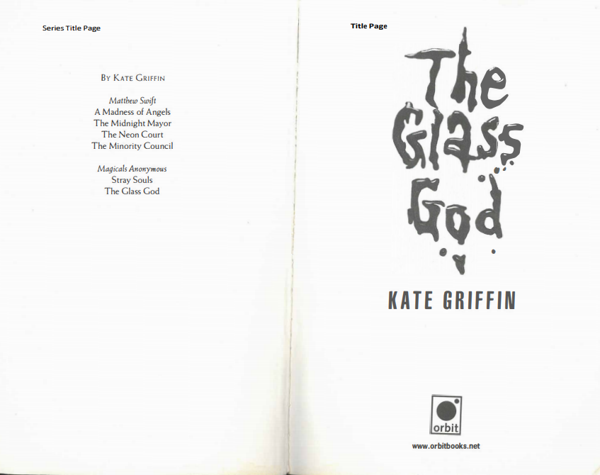

Series authority from LC:

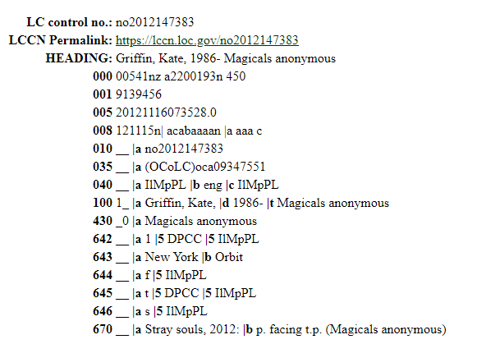

**Part 3 – RDA vs AACR2**

Read the document: RDA Refresher Performance Support from the Library of Congress (<https://www.loc.gov/catworkshop/RDA%20training%20materials/RDA-refresh/rdarefr-diffa2.pdf>) .

1. What are 4 differences between the old cataloguing standard, AACR2, and the new standard, RDA?
2. Thinking about the changes that you listed, how do you think they help a user find information?

**Part 4 – Authority Control**

Read the article listed below. Write a summary of the article (max 350-400 words). Then write a reflection about the article (max 250 words). Some questions that you could consider are:

* What was the most important thing that you learned from the article?
* If you were a cataloguer, how would the article impact your work?
* Were you surprised by anything discussed in the article?

Wiederhold, R.A. & Reeve, G.F. (2021). Authority control today: principles, practices, and trends. *Cataloguing & Classification Quarterly, 59*(2-3), 129-158. DOI: 10.1080/01639374.2021.1881009

You are required to include in-text citations and a bibliography for your summary. It should be in proper paragraph/essay format.